|  |  |  |  |  |
| --- | --- | --- | --- | --- |
|  |  | |  | | --- | | - | |  | |
|  |  |  |
| Annual Report 2020 |  |  |

**A Message from the Executive Director, Gerald Starr**

VISION 2021

The West Side Hospital District was formed October 20, 1947 and has served the Westside of Kern County in hospital-based and outpatient health care for over 73 years!

Our Vision for 2021 is based on several major milestones achieved by the West Side Health Care District between 2017 and March of 2020. First, West Side Family Health Care--the Clinic owned and operated by the District--continues as a federally certified Rural Health Clinic since January, 2017. This first Milestone recognized improvement in the operation of the Clinic and achieved increased financial payment for our patient services. Our second major Milestone was the design, funding and construction of the expanded West Side Family Health Care Clinic at 100 E. North Street. The project design team worked throughout 2017 and half of the year 2018 to design and publicly bid the expanded West Side Family Health Care Clinic project.  The construction phase began in August of 2018 and was completed when operations began with a ceremonial ribbon cutting on March 13th of 2020. The project cost was financed by cash reserves from the District and a generous donation from the Fred and Barbara Holmes Foundation of $4,000,000. With this generous donation there were no additional taxes or public funds contributed to the project. There will be no long-term debt associated with the project. The new primary care and walk-in Clinic has 9 patient examination rooms and 3 additional patient treatment areas as well as Clinic operations and support space. The Clinic’s expanded reception and waiting areas for patients and family members are professionally designed and decorated with stunning art work. The next major Milestone is still in motion. The Radiology service continues to serve Clinic patients as well as the patients of other providers in our service area with diagnostic X-Ray services. The WestPac Laboratory services has relocated their specimen collection services to what is now Building B of West Side Family Health Care.  In the remaining space now available in Building B the District continues a strategic objective to design, and fund a project to provide dental services for the poor and underserved of the District. With Building A—the new Clinic space—there is sufficient space and support resources, to expand the services available to the citizens of the District. With the future of value-based reimbursement for patient care management our providers are supported with a state-of-the-art Electronic Medical Record for documentation and quality review of patient care. Our primary care patient care services have expanded with the availability of a full-time Board-Certified Family Practice physician. We continue to have the support of a Board-Certified Medical Director providing primary care and consulting in Emergency Medicine. We also have a dedicated staff of certified Nurse Practitioners and a Certified Physician’s Assistant to support both primary care and walk-in services. We encourage patients to use our appointment system by telephone or website to support their primary health care management. The Clinic has added Chiropractic Medicine services and will soon implement Podiatry Services in scheduled specialty Clinics. With a full-time Family Practice physician, the Clinic will be expanding Women’s Health Services and other family healthcare services. The District is committed to our mission-history of offering extended hours of Clinic operations and our walk-in services for urgent care needs.  We continue to serve the District 365 days with evening hours, weekends and holidays. Our five-member District Board will continue formal planning and continues to be committed to our mission of meeting the primary health and wellness needs of the families and citizens of the West Side Health Care District.

***Our History***

The West Side Hospital District was created in 1947 and operated the West Side District Hospital in Taft from 1952 until 1998. The District sold the Hospital to Catholic Healthcare West (CHW) in 1998. In 2003 CHW closed the Mercy Westside Hospital. In another location the District opened a small urgent care clinic in 2004.

On December 22, 2008, the District purchased the closed Hospital property from CHW which included a separate outpatient clinic. The District initiated some renovations and modifications and the facility opened in March of 2010 as West Side Urgent Care. The expanded Urgent Care included Digital radiology and Clinical Laboratory services.

In 2015 the District Board made the strategic decision to address the need for improved/enhanced access to primary care for the citizens and communities of the West Side Health Care District. A plan was set in motion to convert the Urgent Care Clinic to a federally certified Rural Health Clinic. That goal was achieved with CMS certification of the West Side Family Health Care Clinic effective January 12, 2017.

Our well-versed Medical Staff consist of our Medical Director and Emergency Medicine Physician, Dr. Ostrom DO, one full time Family Medicine and 2 specializing in Emergency Medicine. Along with our Medical Staff, we also offer Telemedicine, as well as Chiropractic Services. With such an abounding and diverse medical and Chiropractic Staff, we are able to meet the daily health needs of our community 365 days a year. With the help of our medical staff, we are also able to participate in such programs as Vaccines for Children (VFC) and Children’s Health and Development Program (CHDP)

The District in March 2020 completed construction of a $9,000,000 Outpatient Clinic expansion project of approximately 12,800 square feet. The new space includes additional treatment space(s) and separate adult and pediatric clinics plus operational support space.

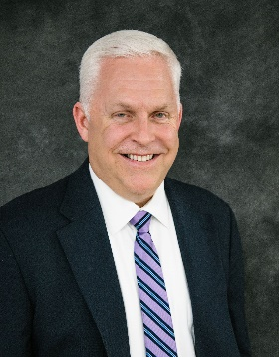

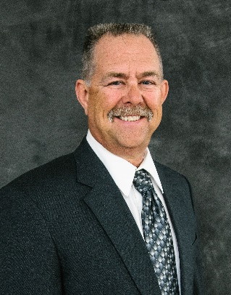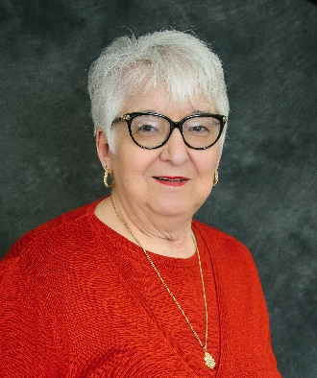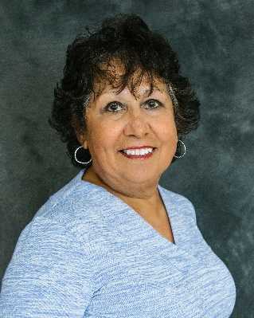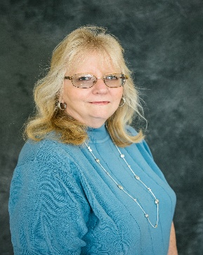

Virginia Miller

Secretary/Treasurerer

*“As a rural health care district* *dedicated to the healing arts, we are committed* *to meeting the challenges of the future* *by preserving quality health care services* *for the needs of the Westside community* *we serve.”*

|  |  |
| --- | --- |
|  |  |

***Our Mission Statement***

Darren Walrath

Board Member

Janice Ashley

Board Member

Adele Ward

Vice President

Eric Cooper

President

Board Meetings

Board meetings are held on the 4th Thursday of each month at 2:00pm.

Located at the West Side Health Care District Office

119 Adkisson Way • Taft, CA 93268

_____________________

Regular meetings of the board are open to the public.

Agendas are posted 72 hours in advance of meetings.

(WSHCD Admin Office • WSHCD Website)

Contact the administrative office for additional information or special needs assistance.

____________________

***Our Structure***

***Board of Directors***

*In the chart below, each committee is outlined. Each committee meets separately on an as needed basis. Each committee presents a verbal report of the committee’s functions at the monthly schedule Board meeting.*

*Board Committees*

Janice Ashley

Adele Ward

Darren Walrath

Janice Ashley

Eric Cooper

Darren Walrath

Eric Cooper

Virginia Miller

Personnel Committee

Community Outreach

Facilities Committee

Finance Committee

|  |
| --- |
| Our Providers |

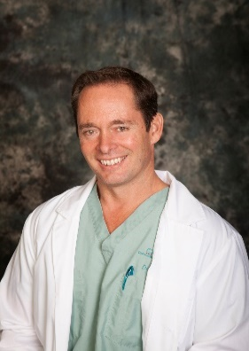

***Ronald J. Ostrom, D.O.***

***Medical Director***

 Dr. Ronald Ostrom is an Emergency Medicine physician in the county of kern. He is affiliated with multiple hospitals in the area, including Bakersfield Heart Hospital, Mercy Hospitals of Bakersfield, as well as the Medical Director for Hall Ambulance. Dr. Ostrom received his medical degree from the College of Osteopathic Medicine of the Pacific and has been in practice for 20 years. He is one of seven providers, as well as the Medical Director of the West Side Family Health Care Facility. Dr. Ostrom resides in Bakersfield with his wife and two children.

#### ***Dorian Reed, Physician Assistant-Certified***

Dorian Reed has been a practicing Certified Physician (PA-C) Assistant since 2005, he specializes in Acute Care, Emergency and Sports Medicine. Although Dorian is from the San Diego area, he has practiced in Kern County since 2015. Before becoming a PA-C Dorian served in the US Navy as a Corpsman/Medic for 5 years active duty, then served in the US Coast Guard as a Corpsman/Medic for an additional 3 years.

.

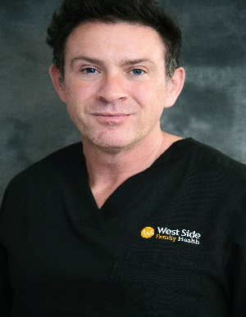

***Heather Bosma, MSN, RN, PHN, FNP-C***

Heather Bosma graduated with her Bachelor of Science in Nursing from Fresno State in 2005, and began her career as a pediatric nurse at Valley Children’s Hospital in Madera, California and later at Cottage Children’s Hospital in Santa Barbara, California. She continued her education and obtained a Master of Science in Nursing and School Nurse Credential from California State University of Bakersfield in 2010. Heather worked as the school nurse for Taft City Schools and Taft High School from 2008-2012. In 2013 she attended Western University of Health Sciences and received her Family Nurse Practitioner Certificate. Heather is dedicated to providing comprehensive healthcare, and encouraging health promotion in individuals and the community. On her days off she enjoys spending time with her family, being outdoors, and cooking.

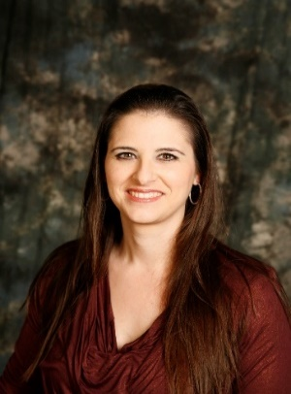

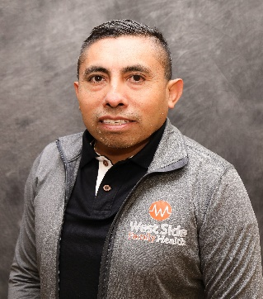

***Abundio Castillo, MSN, RN, PHN, FNP-C***

Abundio Castillo was born in Mexico and moved to the United States of America in 1993. When he came to USA, he did not speak English, therefore, he went to adult school and then enrolled at Santa Barbara City College. In Mexico, he studied Business administration, but always wanted to work in the medical field. In Santa Barbara City College, he met a wonderful mentor that was a nurse, and she guided him to get his LVN and RN license. During his career as RN he held many positions from staff nurse to director and manager of the emergency room at dignity hospitals in Bakersfield. Abundio moved to Bakersfield about 13 years ago, and has been working to serve the Kern County community and he found out that a lot of people lacks the medical care attention, therefore, to better serve our community, he went back to school to become a Family Nurse Practitioner. He graduated in 2018 from Charles R. Drew University School of Medicine and Science. Since then, and has been working at Memorial Hospital ER, Priority Urgent Care and currently at West side Family Health Care Clinic in Taft. Abundio is bilingual in Spanish and English. He feels much rewarded to be able to help our Kern county community. Abundio is happily married and has 4 children.

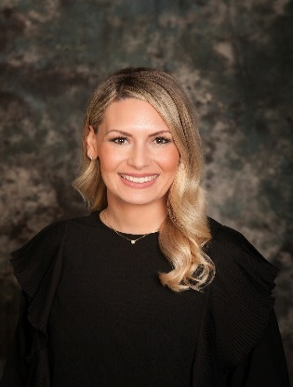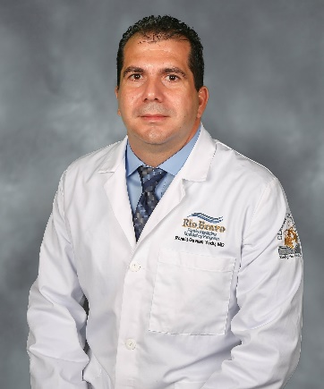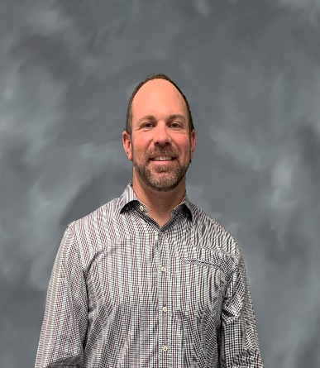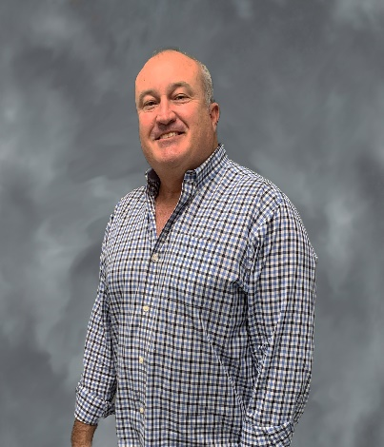

***Elizabeth White, MSN, RN, FNP-C***

Beth is a Family Nurse Practitioner and Board Certified by the American Association of Nurse Practitioners Born and raised in Bakersfield, CA; she began her nursing career in 2011, working as a Registered Nurse in the Intensive Care Unit. Beth holds both a Bachelor’s Degree and Master’s Degree in Nursing from California State University, Bakersfield.

Beth is dedicated to serving the residents of West Kern County. She is qualified to diagnose and treat a wide array of conditions across the entire lifespan and believes in working collaboratively with each individual to achieve their best possible state of health.

#### ***Ronald Gavilan, MD, Family Practice Physician-Certified***

Ronald Gavilan, comes to West Side Family Health Care from the Rio Bravo Family Residency Program in Bakersfield, CA where he just completed his residency as the Chief Resident. He attended Medical School in Santiago de Cuba, and did a residency in Family Medicine as well in Radiology. He practiced as radiologist and family medicine for several years in Cuba, Guatemala, and Guyana.  When he first came over to the United States, he worked for some time as a medical sonographer in Reproductive Medicine, Rosalind Franklin University Health System. Dr. Gavilan specializes in full spectrum primary care, with a special interest in Prenatal Care, Women's Health, and Point-of-Care Ultrasound. He is fluent in Spanish.  Dr. Gavilan is married with 1 daughter, and enjoys cooking, traveling, and spending time with family and friends in his free time.

#### ***Eric Walker, Doctor of Chiropractic***

Dr. Eric Walker is a licensed and Board-Certified Doctor of Chiropractic since 2008. He also has a Certified Chiropractic Sports Physician (CCSP®). Dr. received his BS in Kinesiology (Pre-Physical therapy) from San Diego State University and his Doctor of Chiropractic degree from Palmer College of Chiropractic West in San Jose, CA. He is also currently a co-owner of Active Life Chiropractic in Bakersfield, CA. Dr. Walker resides in Bakersfield with his wife and 3 children.

#### ***Jason Sabol, Doctor of Chiropractic***

Dr. Jason Sabol is a licensed and board-certified Chiropractor in California and has been practicing 23+ years. He earned his chiropractic degree at Palmer West Chiropractic College. He is a Bakersfield native who resides in Bakersfield with his wife and 2 children. His years of experience has allowed him to treat injuries and conditions of patients with great success through chiropractic care.

* In addition to full time providers, our medical staff includes per diem providers who are trained in a variety of disciplines such as Internal Medicine, Emergency Medicine, and Family Practice.

### District Leadership

|  |
| --- |
|  |

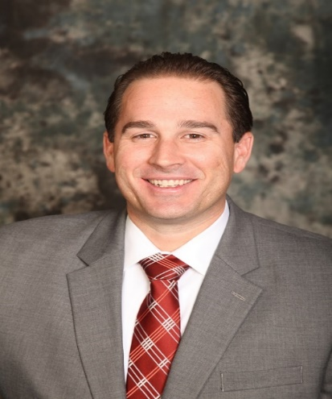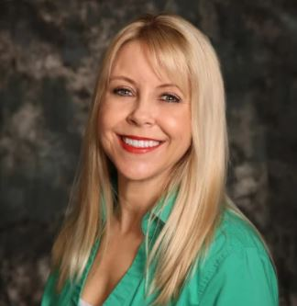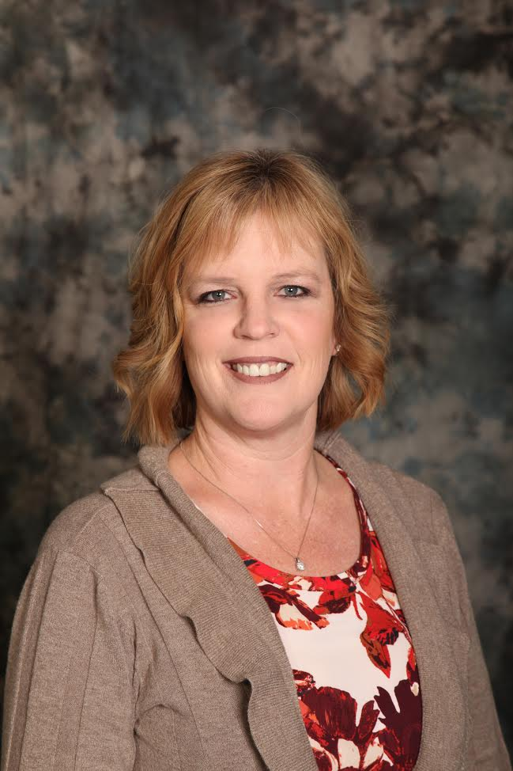

***Summer Wood-Luper, Clinic Director, BSN, PHN***

Raised in the Pacific Northwest, Summer has a true love of nature, enjoying exercise, outdoor activities, and community events. After meeting her husband and completing her Associate in Arts degree at Taft College, she went on to pursue her Bachelor of Science in Nursing and Public Health Nursing License at California State University Bakersfield in 2008. Now married with two children, Summer has chosen to make Taft her home and has resided here since 2002. She is committed to helping her community members attain the highest level of health and wellness through her role as Clinic Director.

***Ryan Shultz, Director of Clinical Operations***

Ryan was born and raised in Bakersfield, CA, and graduated from Westmont College with a degree in Political Science. Ryan earned his Masters of Science in Health Care Administration from California State University Bakersfield. He is also a graduate of the Kern Leadership Academy. Previously, Ryan served the Westside as staff to Kern County’s Fourth District Supervisor. As a part of his graduate studies, Ryan’s thesis analyzed best practices for a Rural Health Clinic. As Director of Clinical Operations his duties include oversight and management of the Clinic’s operations and the District’s revenue cycle. Ryan is married to Brittany and together they have two children Emery and Everett.

E-mail Ryan at rshultz@wshcd.org

***Robyn Melton, District Manager***

Born in Taft, and a lifelong resident of the Westside, Robyn is proud to be part of such a great community. An active member of the Taft Kiwanis club, she loves participating in community service. She also serves as a Board member for the West Side Cemetery District. Robyn has been employed with the District since April 2008 and serves as Clerk of the Board. She is responsible for overseeing all of the day to day operations of the District, as well as handling many HR-related activities. She looks forward to all the wonderful progress and growth in store for the Taft Community. Robyn enjoys camping and traveling with her family. She is married to her husband Steven, they have three grown children.

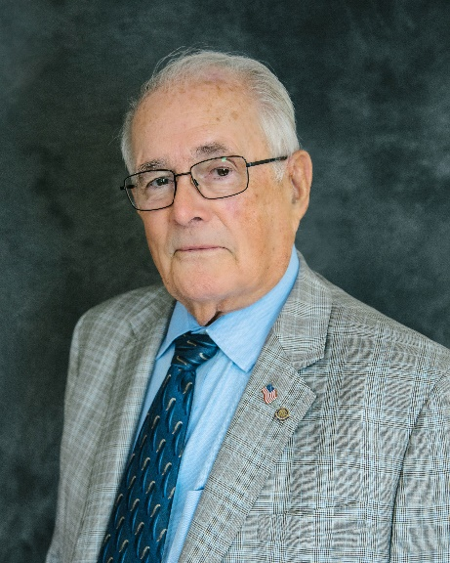

***Gerald A. Starr, District Office Executive Director, MPH, FACHE***

Gerald (Jerry) was born in Jerome, AZ. Jerry graduated from the University of Oklahoma with a degree in Business Administration and received a commission as a Second Lieutenant in the Medical Service Corps. Jerry later earned his Masters of Public Health degree from Yale University. Jerry left the Air Force with the rank of Major with over 23 years of active service. Jerry’s has served Kern County for over 30 years in CEO, COO and Vice President Positions at Bakersfield Memorial Hospital, Kern Medical Center, Mercy Hospital and Delano Regional Medical Center. Jerry is married to Robin. He is a Charter Member and Past President of the Rotary Club of Bakersfield Breakfast. Jerry also enjoys volunteer work in his Church, as a CASA Advocate, and serving at the Guild House in support of the Henrietta Weill Memorial Child Guidance Clinic.

[](http://www.google.com/url?sa=i&rct=j&q=&esrc=s&source=images&cd=&cad=rja&uact=8&ved=0ahUKEwj77dHt8rHWAhVV5GMKHYybBwAQjRwIBw&url=http://orangehc.com/&psig=AFQjCNEhEv88N2u58DLTOt_99M6v5EGolw&ust=1505932761016019)

Health Services

**Family Practice** • **Pediatrics** • **Urgent Care** • **X-Ray Services** • **Workers Comp**

***Patients Served: Fiscal Year 2020 (July 1st 2019-June 30, 2020)***

|  |  |  |
| --- | --- | --- |
| *Visit Type* | *Census* | *Patient Lives* |
| Adult | 11,554 | 5,254 |
| Pediatrics | 6,163 | 2,759 |

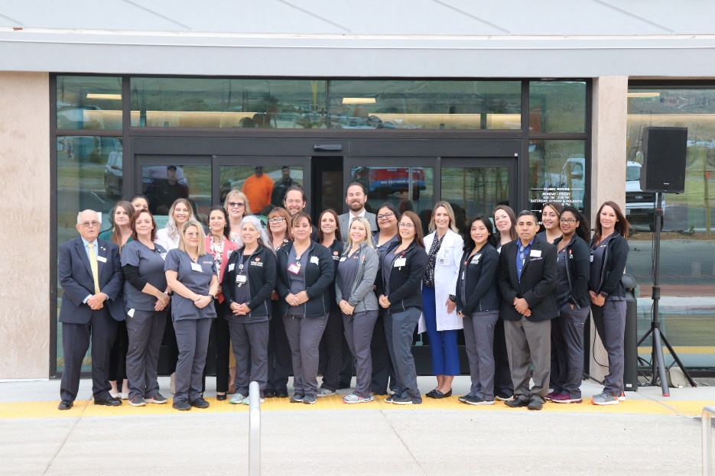

*Grand Opening*

*March 13th, 2020*

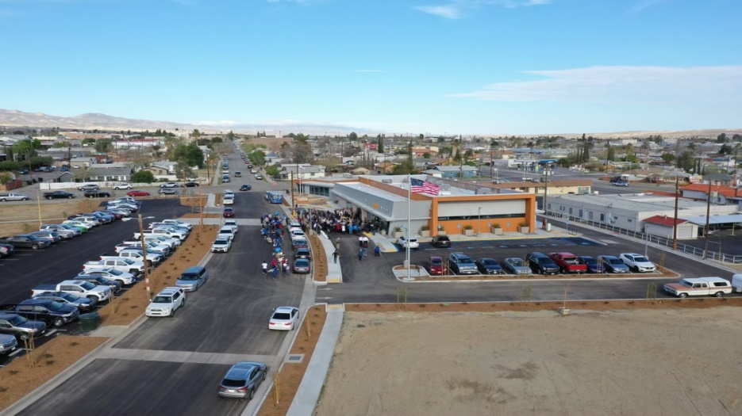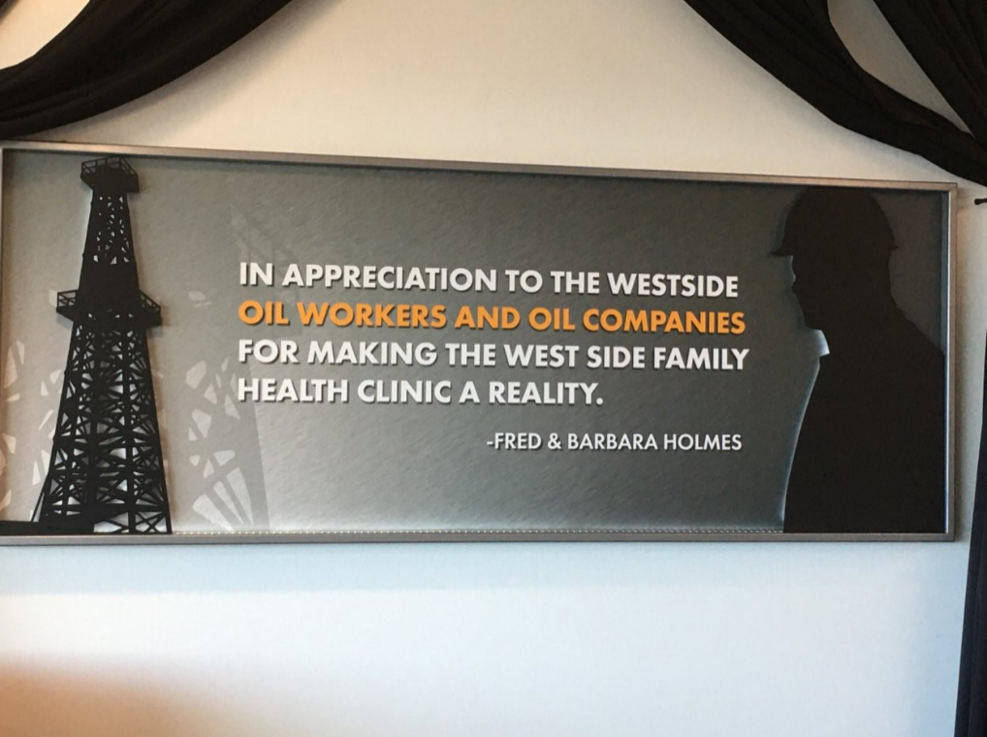Community Outreach

The West Side Health Care District celebrated the grand opening for the new outpatient clinic on Friday, March 13th, 2020.

The ceremony marked a new beginning and another step to rebuilding the community’s health care infrastructure.

“This is a symbol of a new beginning for us,” Health Care District Board President Eric Cooper said.

Taking immense pride in our youth and community, the District and Board members are dedicated to supporting a wide variety of community and charitable activities.

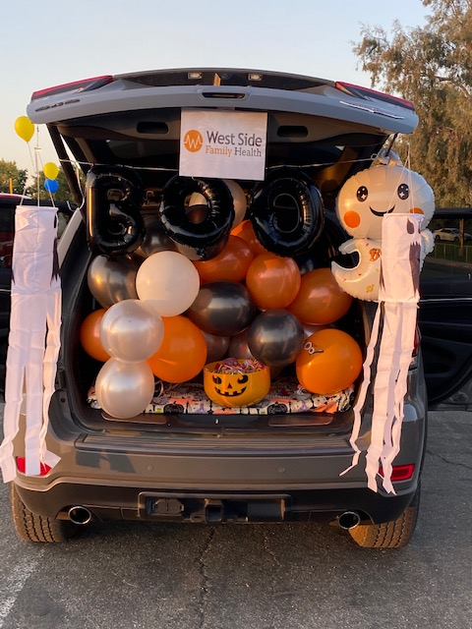Halloween Trunk or Treat



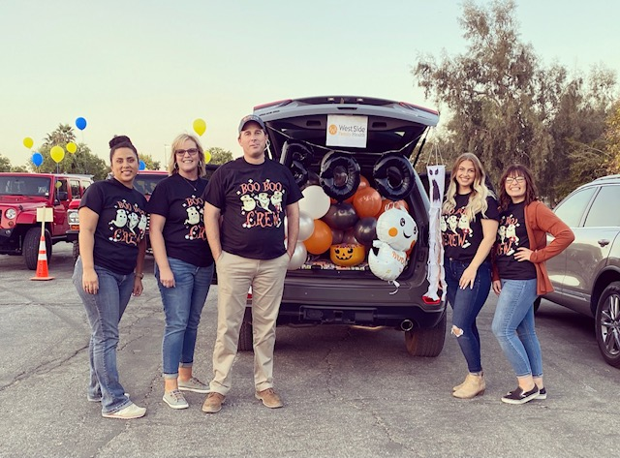

**The District had the opportunity to participate in the community Trunk or Treat event on Halloween.**

[](http://www.google.com/url?sa=i&rct=j&q=&esrc=s&source=images&cd=&cad=rja&uact=8&ved=2ahUKEwiHyp-V1s7bAhU-CDQIHWP-C_4QjRx6BAgBEAU&url=http://actors9.com/candy-corn-clipart/&psig=AOvVaw36e9rIu_h7xPu_RHzc4Fyq&ust=1528911725163138)

Career Day Events

This year was a very unique year. We unfortunately were not able to attend as many community events as we would have liked. We usually attend at least 3-4 Career Days at the schools in our community, but this year we were only able to attend one.

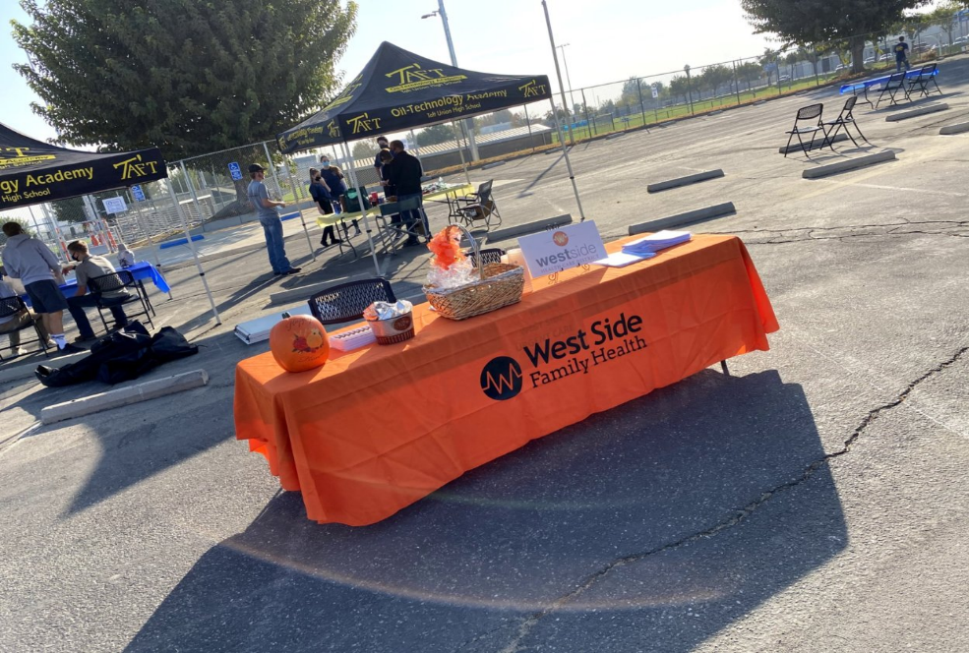

We attended the Career Day at Taft Union High School! This year it was a Drive Thru Career day but we enjoyed it nonetheless. We had a blast being able to socialize with the students of our community while still maintaining social distancing. We shared our experiences working in the Medical Field and all of the different careers there are to choose from.

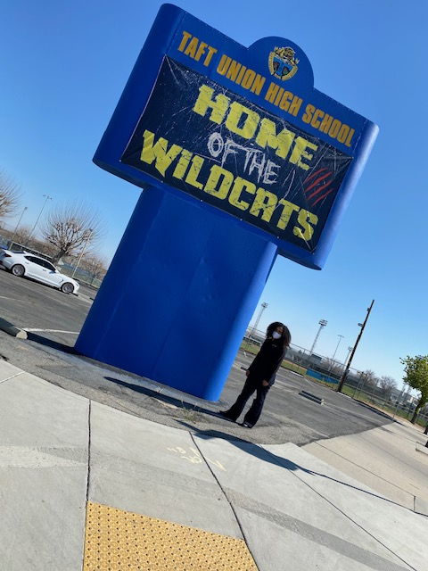

**Taft Union High School**



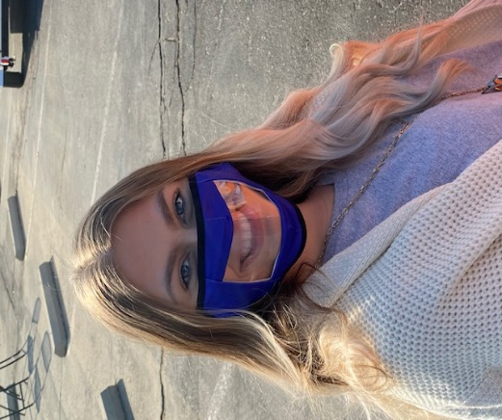

Carrie Coleman standing in front of the Taft Union High Wildcat sign on Career Day.

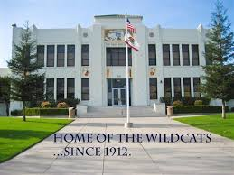

Meghan Bravo supporting her new mask given to the District Staff by the Taft Union High School staff at Career Day!





Breast Cancer Awareness

West Side Family Health Care took pride in hosting their first Mammogram Event in October for Breast Cancer Awareness Month.

This event was well attended and appreciated by our community. We plan to host this every year.

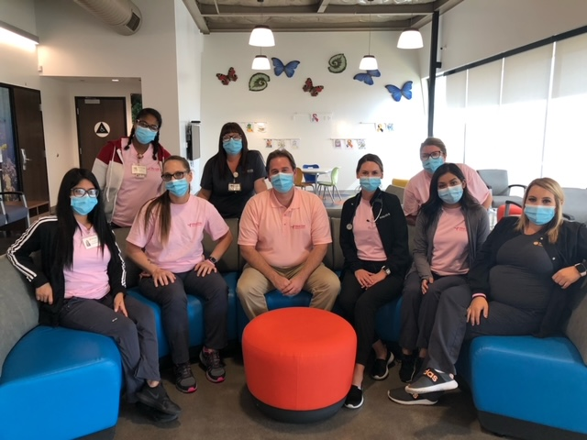

[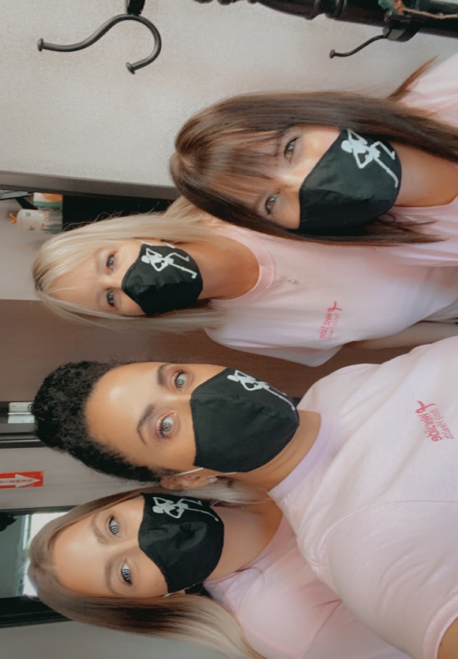](https://www.google.com/url?sa=i&rct=j&q=&esrc=s&source=images&cd=&cad=rja&uact=8&ved=0ahUKEwjpjJey_rPWAhUF-GMKHZwDAZMQjRwIBw&url=https://www.taft.k12.ca.us/domain/16&psig=AFQjCNEsJ3v_L_NONWucNzuFRC_mWz0CTg&ust=1506004474165635)

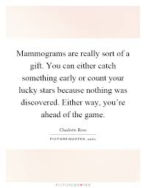

.



***Statements of Revenues, Expenses and Changes in Net Position***

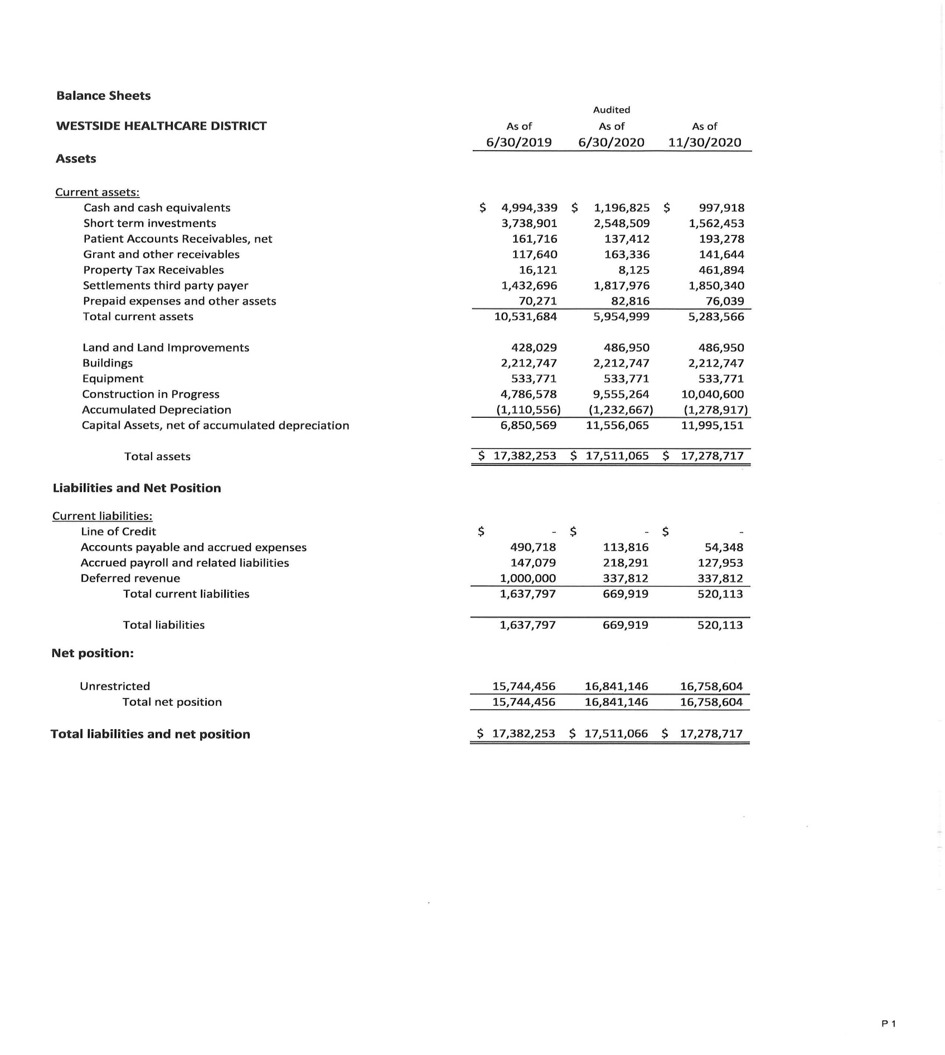 ***West Side Health Care District***

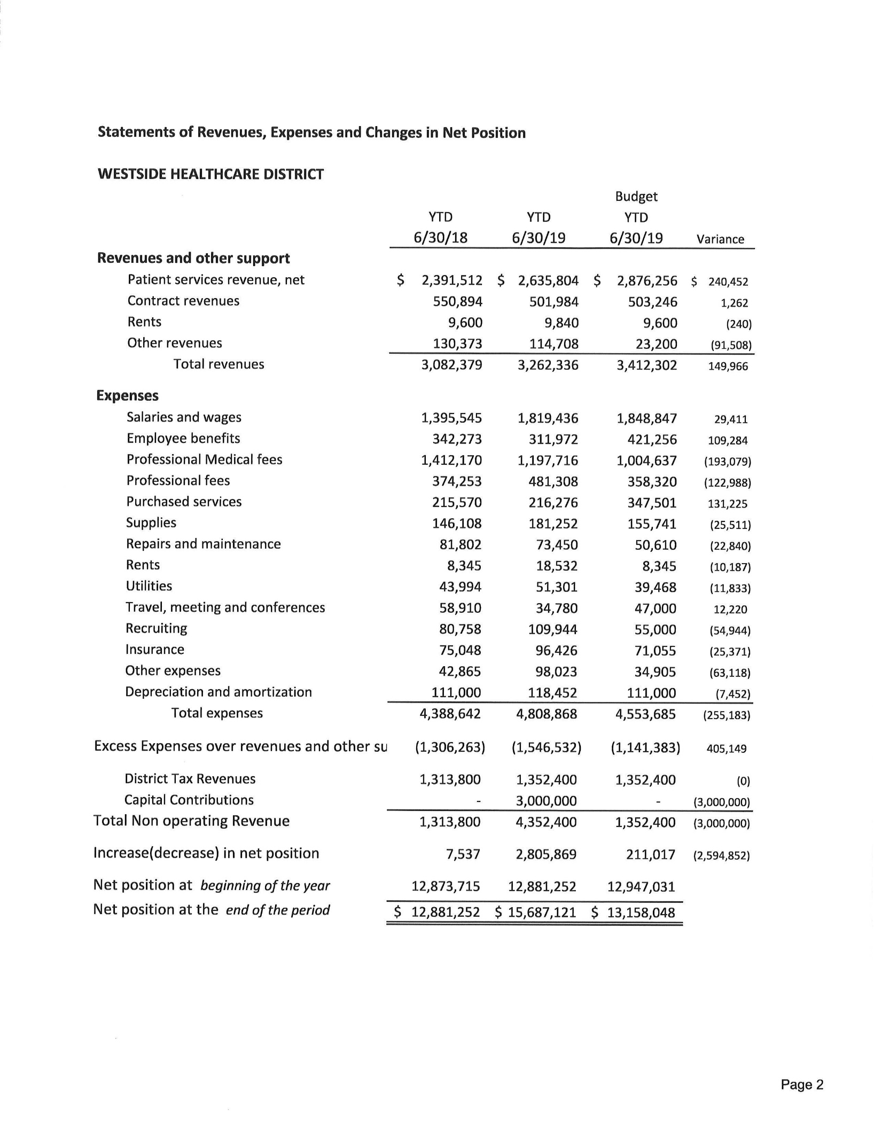

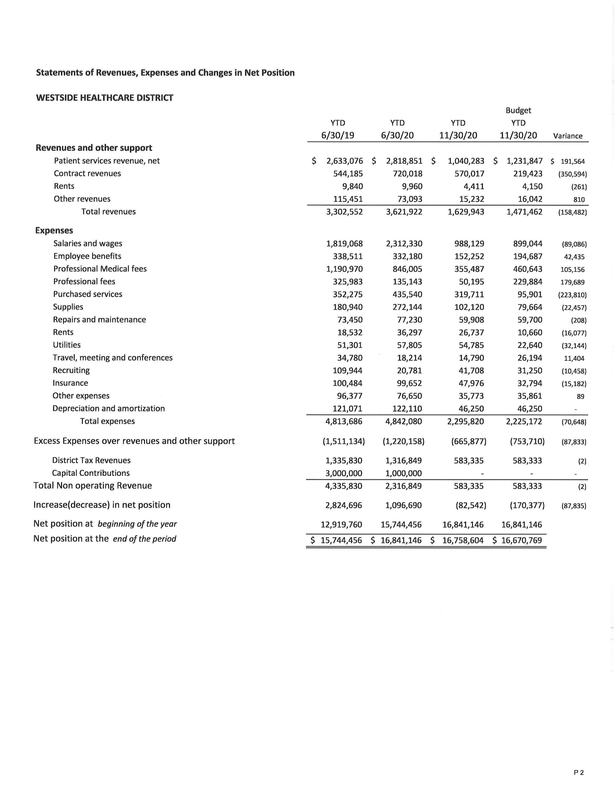

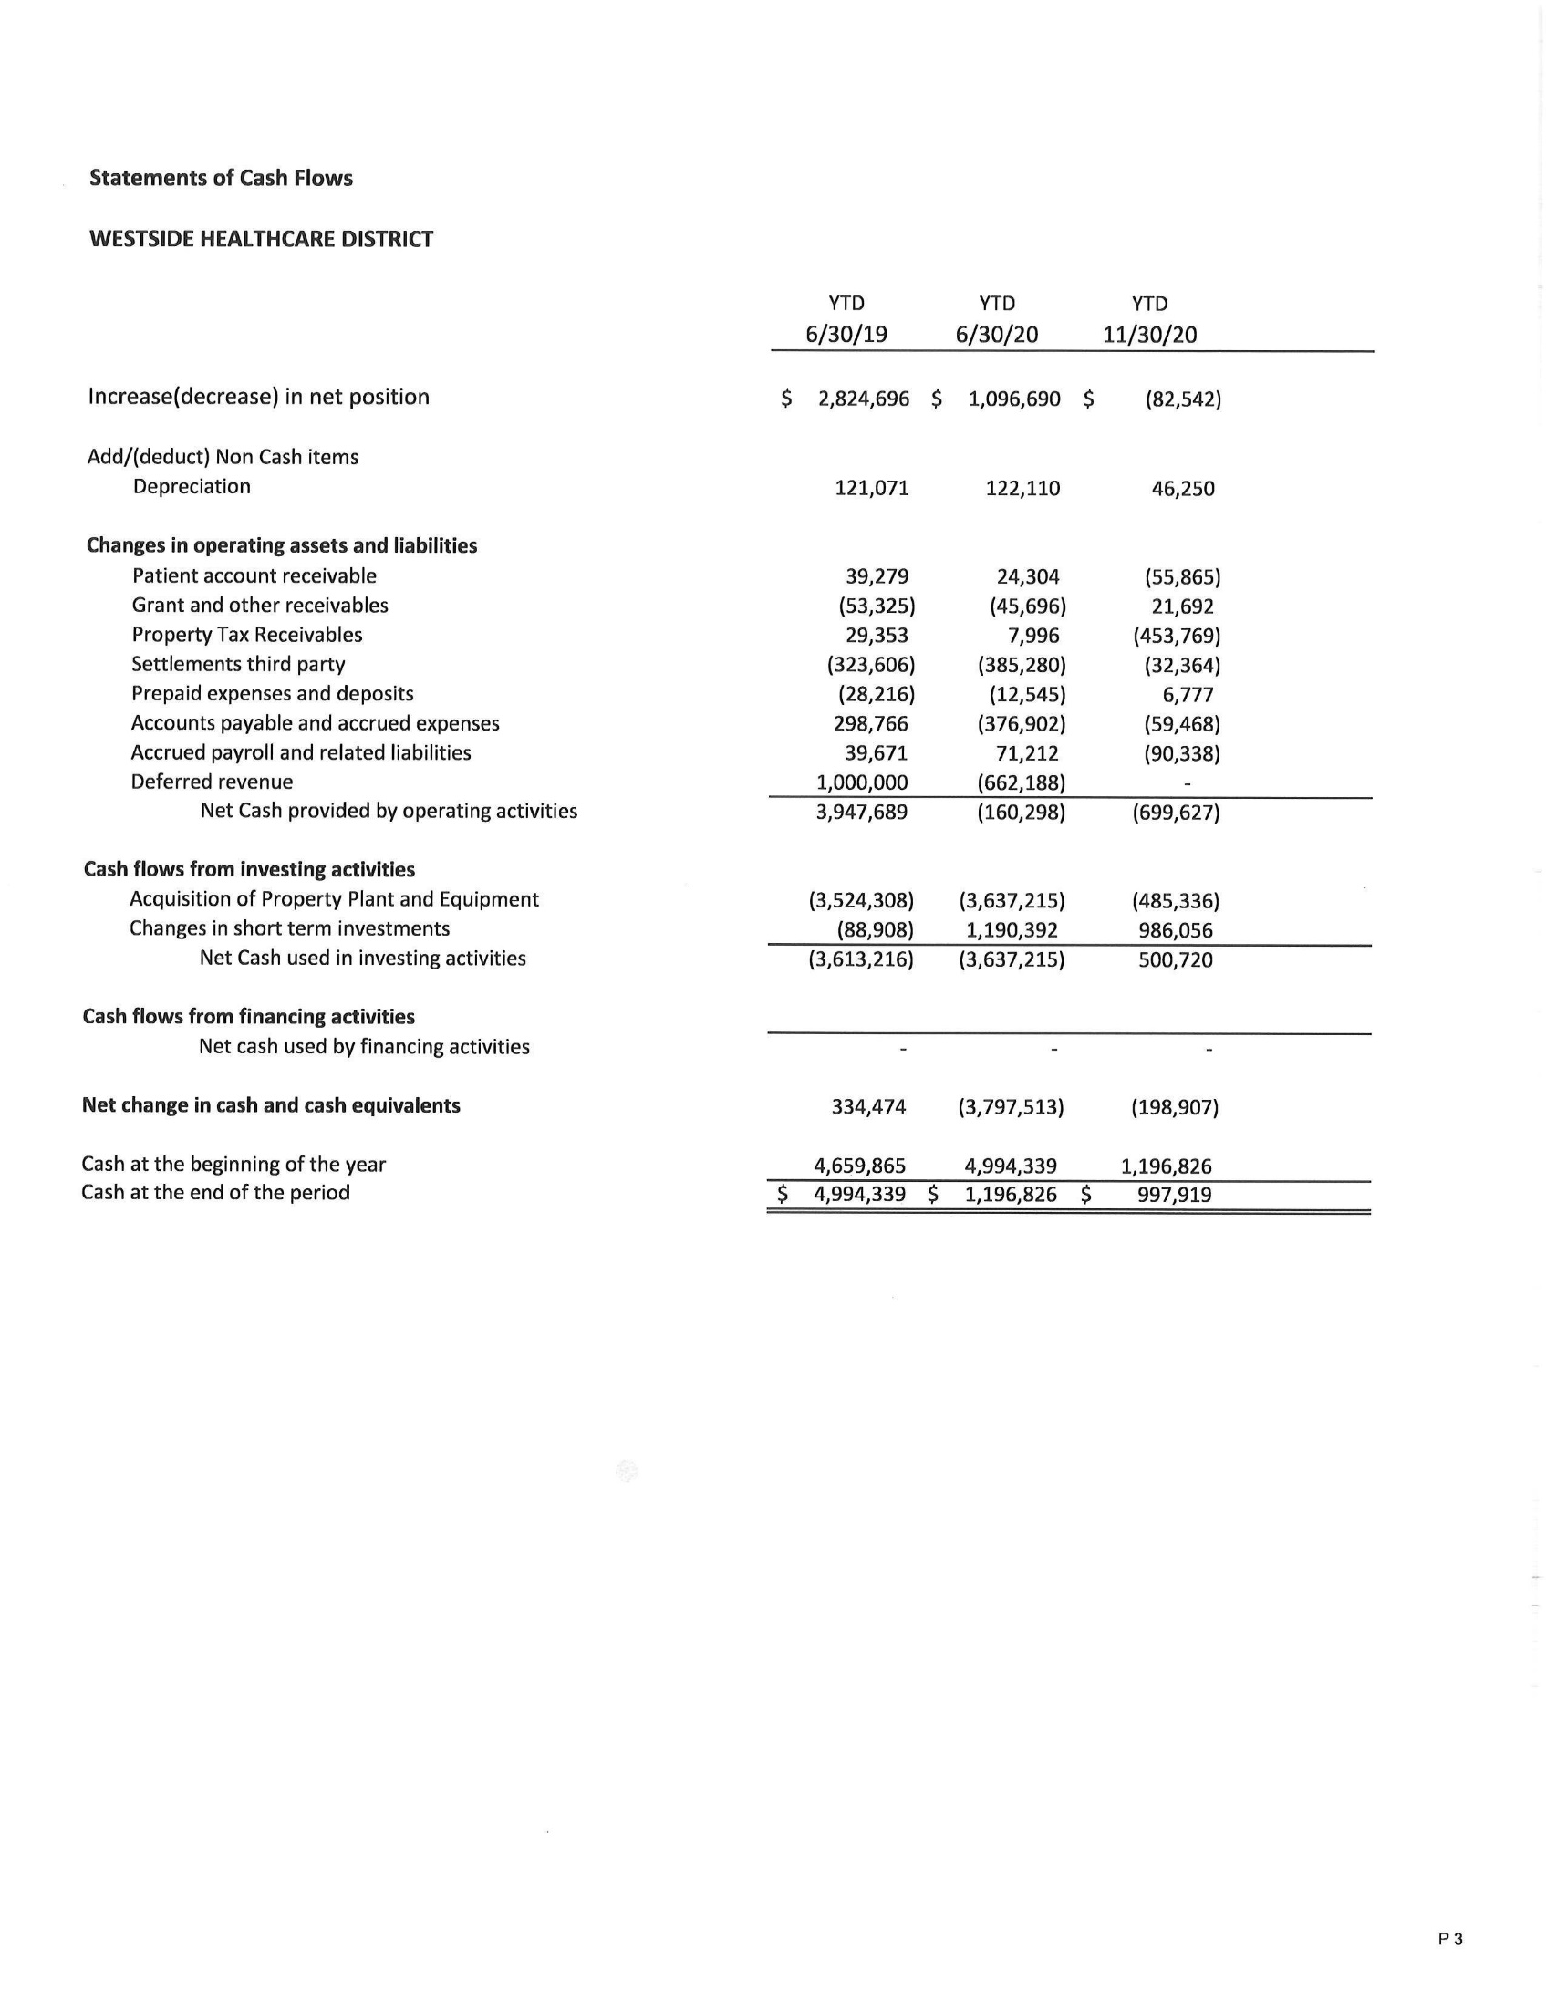

**District Tax Revenues:** The District receives much of its financial support from parcel taxes. These funds are used to support operations and meet required debt service agreements. They are classified as non-operating revenue as the revenue is not directly linked to patient care. Parcel taxes are levied by the County on the District’s behalf during the year, and are intended to help finance the District’s activities during the same year. The County has established certain dates to levy, lien, mail bills, and receive payments from property owners during the year. Parcel taxes are considered delinquent on the day following each payment due date.

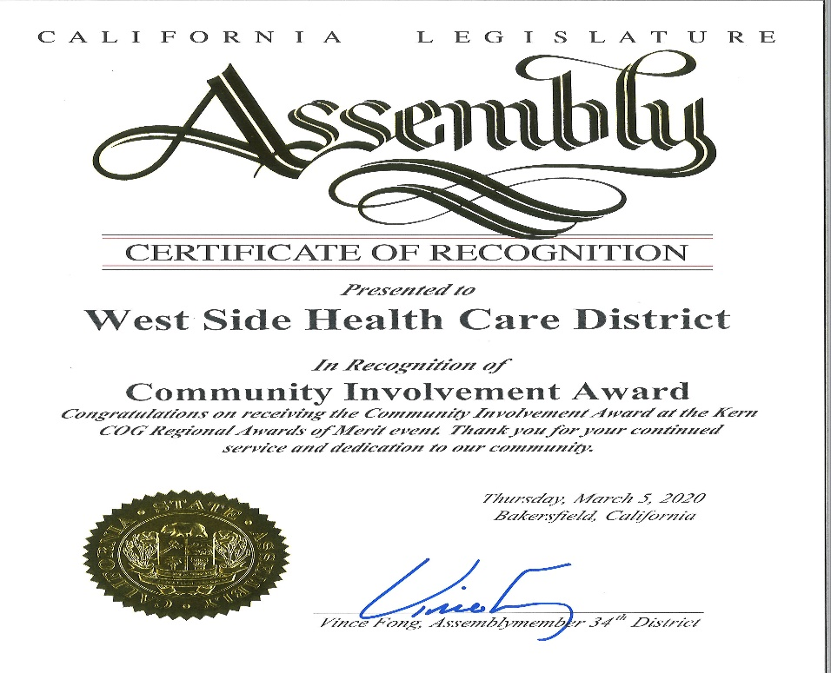

*cog aWARDS*

West Side Family Health was honored at the Kern Council of Governments Annual awards dinner.

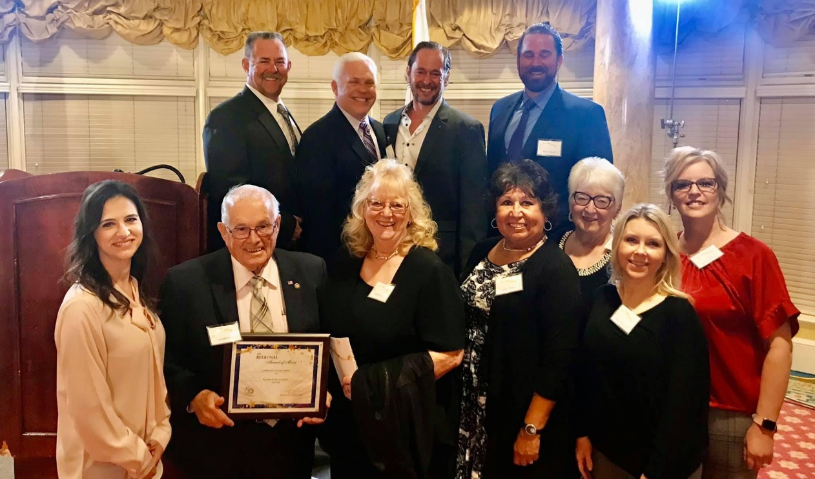

***Directory***

|  |  |  |  |
| --- | --- | --- | --- |
| ***Name*** | ***Title*** | ***Email*** | ***Phone Number*** |
| Gerald Starr | Executive Director | [gstarr@wshcd.org](mailto:gstarr@wshcd.org) | Office: 661-765-7234  Direct Line: 661-745-4924 |
| Ryan Shultz | Director of Clinical Operations | [rshultz@wshcd.org](mailto:rshultz@wshcd.org) | Office: 661-765-7234  Ext. 209 |
| Ronald J. Ostrom, D.O. | Medical Director | [rostrom@wshcd.org](mailto:rostrom@wshcd.org) | Office: 661-765-1935 |
| Summer Wood-Luper | Clinic Director | [swoodluper@wshcd.org](mailto:swoodluper@wshcd.org) | Office: 661-765-1935  Ext. 123 |
| Robyn Melton | District Manager | [rmelton@wshcd.org](mailto:rmelton@wshcd.org) | Office: 661-765-7234  Ext. 201 |

***District Office***

***Mailing Address:***

119 Adkisson Way

Taft, CA 93268

***Phone:*** 661-765-7234

***Fax:*** 661-765-7284

***District Office Hours:***

Monday-Friday

8:00am-5:00pm

Website: [www.wshcd.org](http://www.wshcd.org)

***West Side Family Health Care***

***Mailing Address:***

100 E. North Street

Taft, CA 93268

***Phone:*** 661-765-1935

***Fax:*** 661-765-1928

***Clinic Hours:***

Monday-Friday

8:00am-9:00pm

Saturday, Sunday, & Holidays

10:00am-9:00pm

Website: [www.wshcd.org](http://www.wshcd.org)

*West Side Health Care district*